**Question 1a + Question 1b**



**Question 1c**

1. Scan program to find a match for any dog with any first parameter.
2. Scan if any of those dogs have a second parameter that equals ‘GermanShephard’
3. No dog can be found with 2nd parameter equal to ‘GermanShephard’

**Question 2**

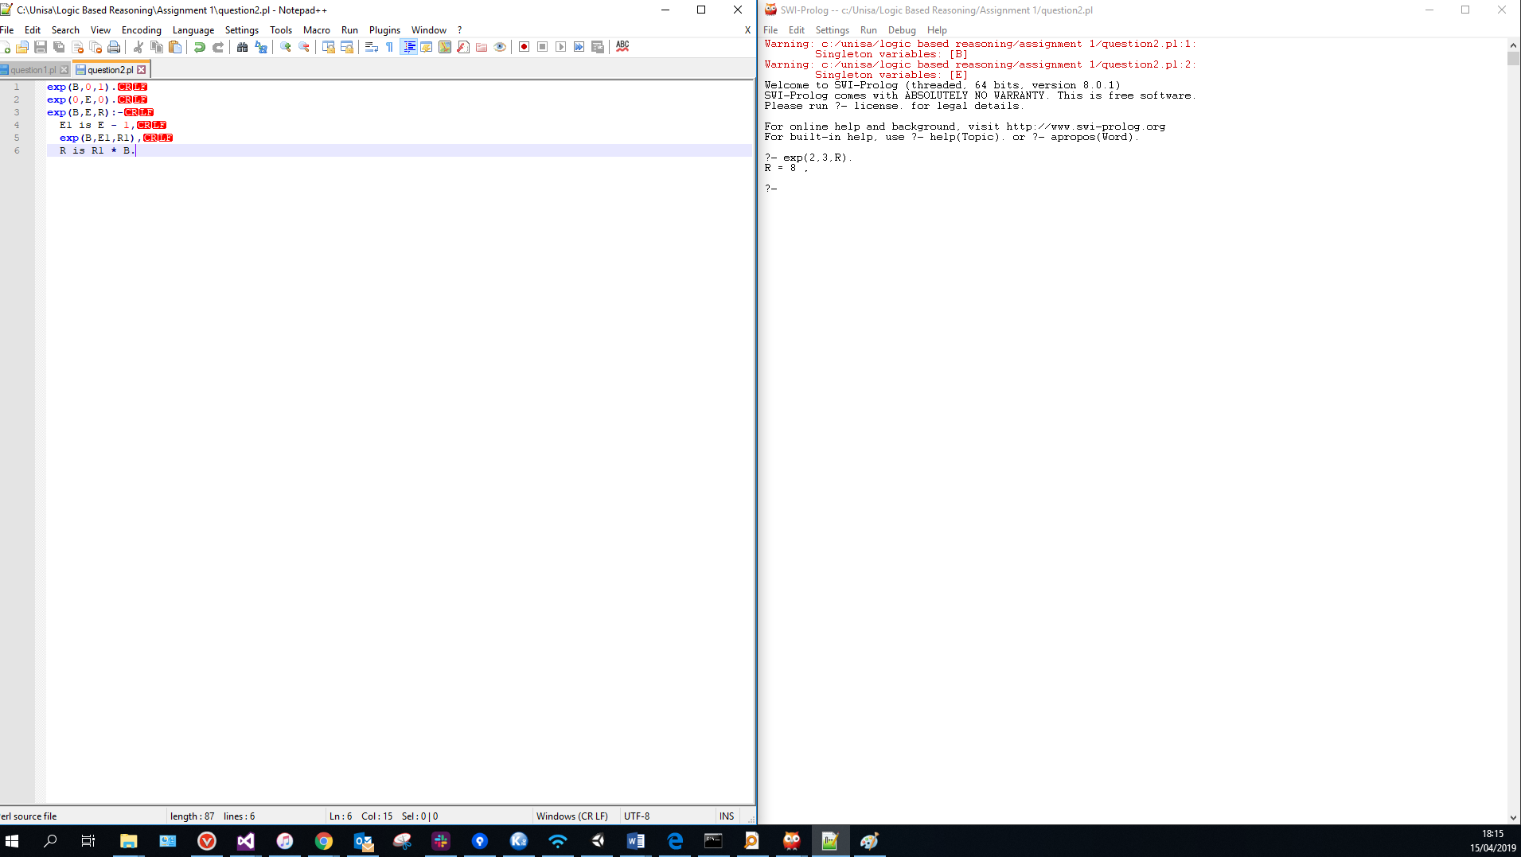

**Question 3**



**Question 4**

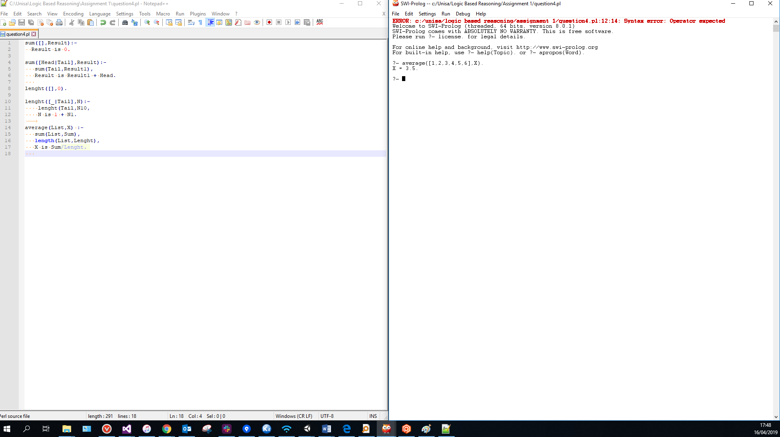

**Question 5a**

Yes

X= [a,b,c,d,e]

Y=[]

**Question 5b**

Yes

X=[a]

**Question 5c**

Yes

X=[predb(1,mill_14)]

Y=[cdc]

Z=[8,9]

**Question 6.a**

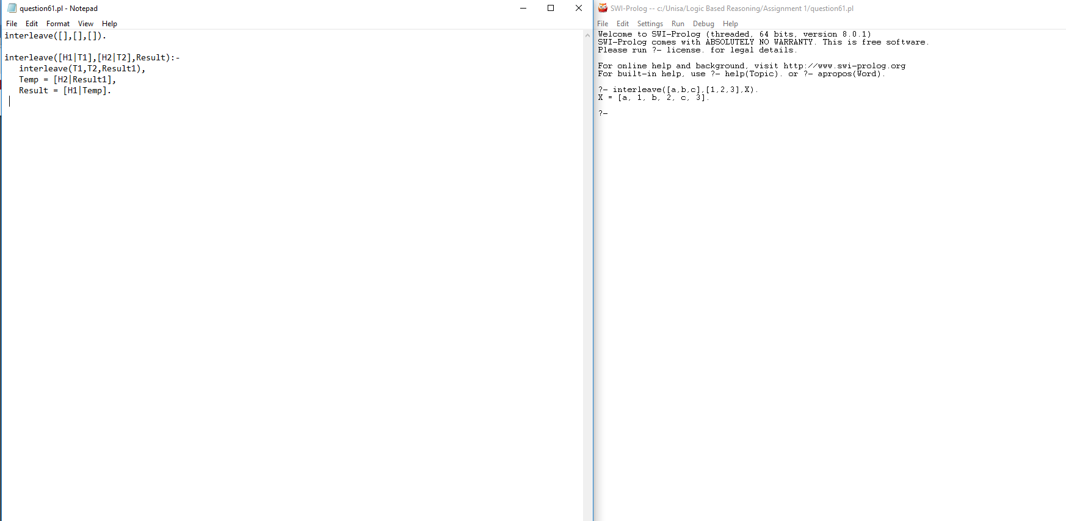

Input is not reversable because that will give a different result

**Question 6b**

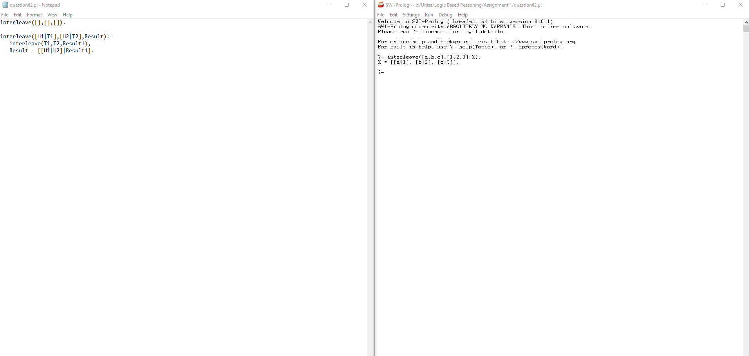

Input is not reversable because that will give a different result

**Question 6c**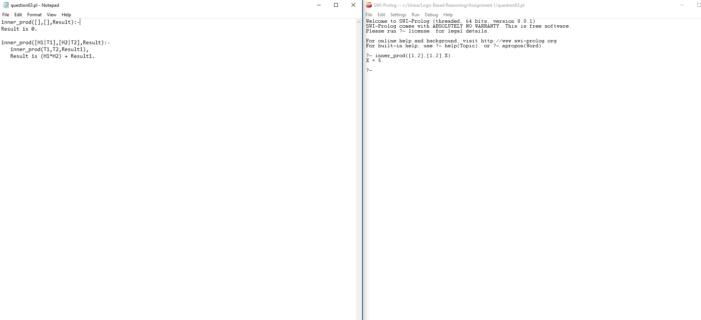

Input is reversable